MEDICINE REMINDER SYSTEM
Linux Shell Scripting Project Report
Subject | OS Linux Lab
Project ID | L84
Project Title | Medicine Reminder System
Programming Language | Bash Shell Scripting
Tools / Utilities | Linux, AWK, SED, Cron, TAR
Guided by | Dr. Anjum Y. Mansuri
Institute | LJ Institute of Computer Applications, LJ University, Ahmedabad

Introduction and Objectives
- The Medicine Reminder System is a menu-driven Bash shell scripting project. It stores a list of medicines and their scheduled times in a CSV file. The user can view the schedule, check the next dose, mark a medicine as taken, update its available stock, view low-stock warnings and review the taken-medicine log.

Objectives
- Maintain medicine details in a simple CSV file.
- Display the daily schedule in time order.
- Identify the next scheduled dose after a user-entered current time.
- Update stock when a dose is marked as taken.
- Warn when stock is below 5 units.
- Maintain a date-and-time log of marked doses.
- Generate reminder checks using a scheduled cron task and create a compressed backup.

Software and Technologies Used
Technology | Purpose in the project
Linux | Operating environment for running shell scripts.
Bash | Implements the menu, loops, conditions and functions.
AWK | Reads CSV records, checks times and updates stock values.
sort | Sorts medicine records by scheduled time.
Cron | Schedules the reminder script to run hourly.
tar | Creates a compressed .tar.gz project backup.

Project Folder Structure
- MedicineReminder/
- main.sh — main menu and program logic
- reminder.sh — scheduled reminder check
- README.md — project instructions
- lib/functions.sh — reusable shell functions
- data/meds.csv — medicine names, times, doses and stock
- logs/taken.log — taken-medicine history
- logs/reminders.txt — reminder check history
- backup/MedicineReminder_backup.tar.gz — compressed backup
- reports/ — project report and evidence

Implementation and Working
The program starts by displaying a menu. A while loop keeps the menu active until the user selects Exit. A case statement handles each menu choice.

Main menu options
- View Medicine List — displays all records from data/meds.csv.
- Today's Schedule — displays the CSV header and sorts medicine entries by time.
- Next Dose — accepts the current time and uses AWK to find the next later scheduled medicine.
- Mark Medicine as Taken — reduces the selected medicine's stock by one and appends the medicine name withthe current date and time to logs/taken.log.
- Low Stock Warning — displays medicines with stock below 5.
- View Taken Log — displays the history stored in logs/taken.log.
- Exit — closes the menu loop.

Reminder and backup
- The reminder.sh script records the time at which it checks the schedule and writes any medicine due at that exact time to logs/reminders.txt. The crontab entry 0 * * * * schedules this script at minute 0 of every hour. The cron daemon must be running for scheduled execution to occur.
- A compressed backup is created with the tar utility. The project archive is stored at backup/MedicineReminder_backup.tar.gz.

Sample Output and Screenshot Evidence

- The following are sample output descriptions. Replace the evidence boxes with screenshots captured from your own terminal before submitting the final report.
Screenshot 1 — Main Menu
- Capture the menu showing all seven options
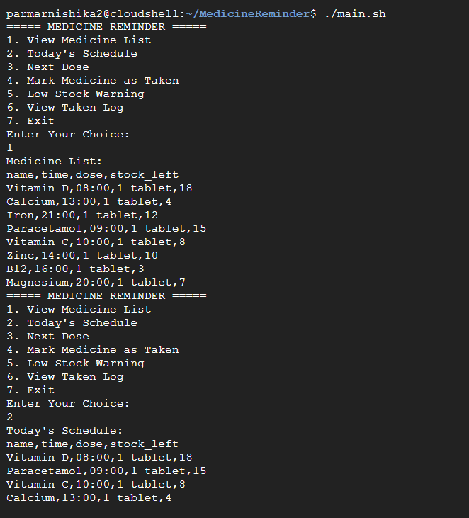

Screenshot 2 — Medicine List and Today's Schedule
- Capture the eight medicine records and time-sorted schedule

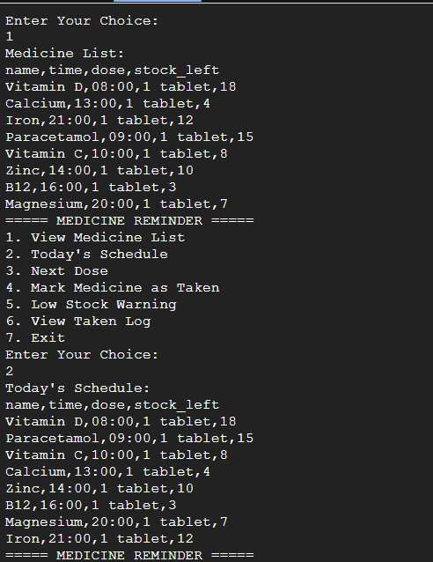

Screenshot 3 — Next Dose
- Capture a test using current time 12:00 and the next dose result
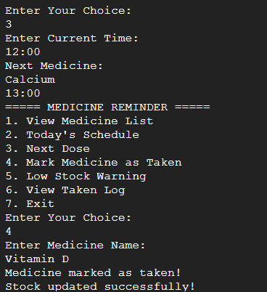

Screenshot 4 — Mark as Taken and Low Stock
- Capture a successful stock update and the low-stock warning
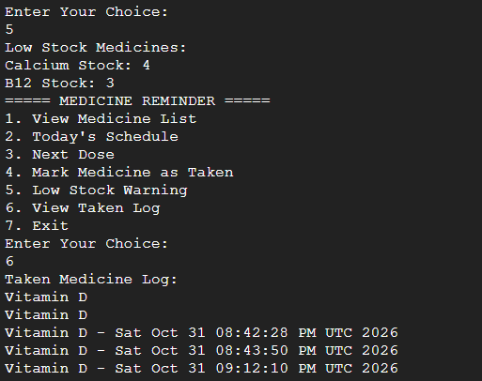
Screenshot 5 — Taken Log and Backup
- Capture the taken log and the backup archive listing
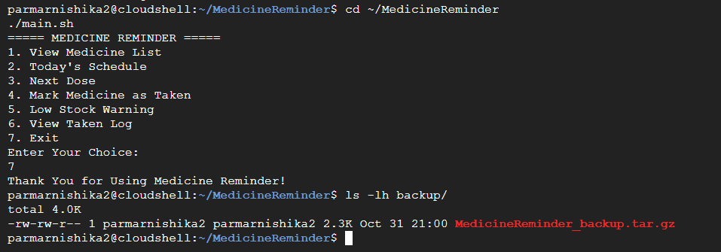
Screenshot 6 — Cron Verification
Capture crontab -l and the cron test result.
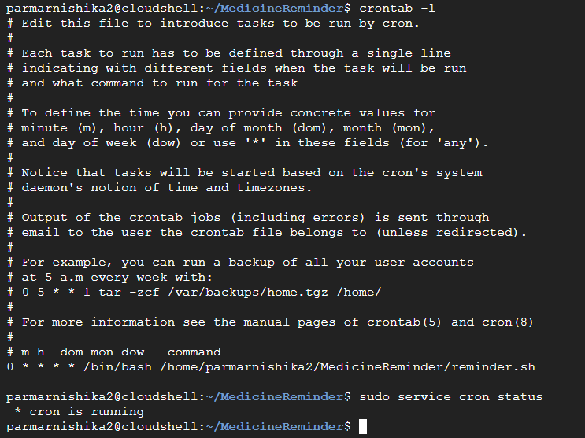

Testing and Results
- The project scripts were checked using Bash syntax validation. The command bash -n main.sh reminder.sh lib/functions.sh completed without displaying syntax errors. The compressed archive was inspected using tar -tzf and contained the main script, reminder script, README, library, data, logs and reports folder.

Functional tests performed
Test | Expected result
View medicine list | All 8 medicine records are displayed.
Today's schedule | Records are shown in ascending time order.
Next dose | The next medicine after the entered time is displayed, or a no-more-doses message.
Mark as taken | Stock decreases by one and a log entry is added.
Low stock | Medicines with stock below 5 are displayed.
Cron test | A test message was written by the every-minute cron test job.
Backup inspection | Archive contents are listed successfully.

Conclusion
- The Medicine Reminder System demonstrates the use of Linux shell scripting concepts such as loops, case statements, functions, file handling, AWK, sorting, logging, cron scheduling and compressed backups. It provides a simple command-line method to view medicine schedules and maintain a simulated stock and taken-dose history.
- Important note: This is an academic software demonstration. The data and reminders are manually maintained and should not be treated as a substitute for medical advice or a verified medication-management service.

Project Guide
- Dr. Anjum Y. Mansuri
- Assistant Professor, Computer Applications
- LJ Institute of Computer Applications, LJ University, Ahmedabad
- GitHub: https://github.com/anjum-mansuri
- Before final submission: add your name and required academic details on the cover page if your teacher asks for them, and replace all screenshot placeholders with genuine screenshots from your terminal.

